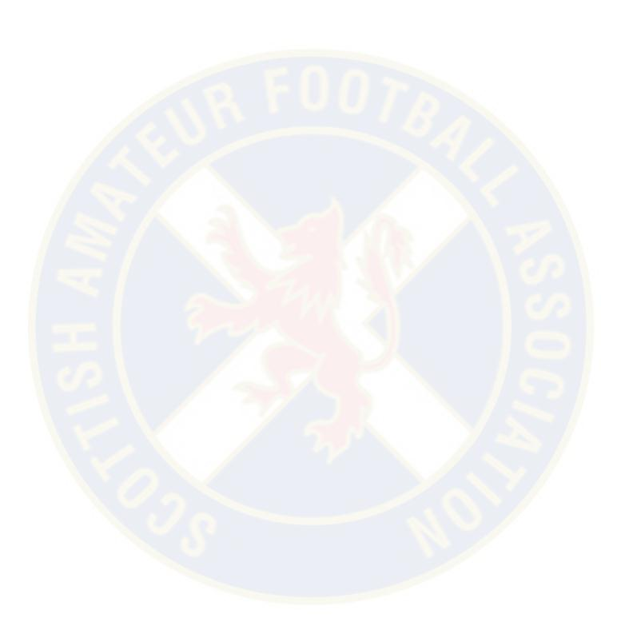
The Scottish Amateur Football Association
Affiliated to the Scottish Football Association
Tournaments
Application Form & Guidelines

Club:
League / Association:
Name of Applicant:
Address:
Post Code:
Telephone Number:
Mobile Number:
E-Mail Address:

Rule 5:
Tournament and Friendly Matches
Clubs wishing to participate in a tournament or friendly match must apply for the appropriate permission as follows: -
Friendly fixture against a club in membership of own Association/League permission of own Association/League
Friendly Match against Club in membership of the Scottish Amateur Football Association. Permission of own League / Association and Scottish Amateur Football Association.
Friendly Match against Club not in membership of the Scottish Amateur Football Association permission of own League / Association, the Scottish Amateur Football Association and where appropriate the S.F.A. Ltd. which will be obtained by the Scottish Amateur Football Association.
Tournaments within and outwith Scotland
Permission of own League/Association, the Scottish Amateur Football Association and where appropriate the S.F.A. Ltd. which will be obtained by the Scottish Amateur Football Association.
Any match which takes place without the necessary permission will be deemed to be unauthorised football and will be referred to the relevant committee which may result in disciplinary action being taken against the Club involved.
The reasons for any member club failing to adhere to the requirements of this rule will be investigated by the Executive Committee and if deemed unsatisfactory the defaulting club will be fined a sum not greater than £50.00.

Opponents & League / Association | Date of Match  DD/MM/YY | Opponents Town or City | Town or City & County of Venue

Notes
All application must be accompanied by a copy of tournament rules.
A translated copy of the tournament rules (if necessary).
Proof of approval by the National Association of the Organisers.
A list of participating clubs stating the National Associations to which they belong.
If the tournament involves participating from more than one country, proof of approval by UEFA.
Proof of insurance cover where necessary.
Organisers of tournaments which require approval from UEFA must submit their application together with all necessary information no later than twelve weeks before tournament is due to commence.
For any further information on friendly matches you are advised to contact:
The National Secretary
Scottish Amateur Football Association
Hampden Park
Glasgow
G42 9DB
0141 620 4550
safa@scottish-football.com

Agreed by  League / Association: | League / Association  Secretary Signature | Date:
Subject to SAFA Approval

